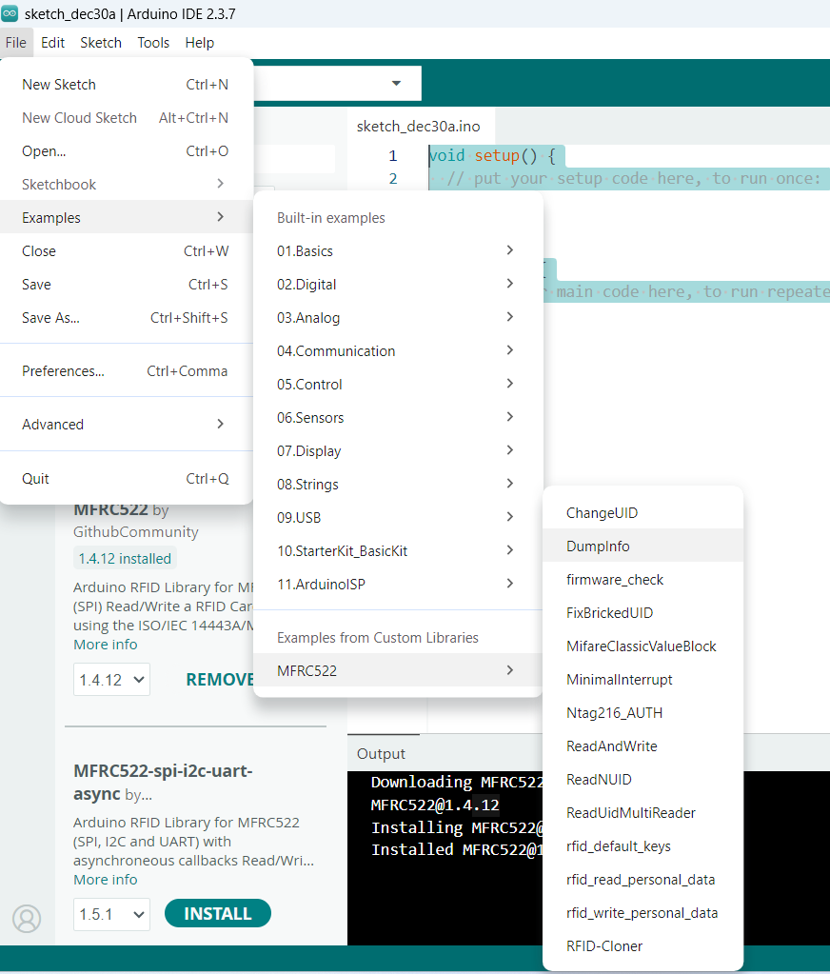
ChangeUID Code:

/*
* --------------------------------------------------------------------------------------------------------------------
* Example to change UID of changeable MIFARE card.
* --------------------------------------------------------------------------------------------------------------------
* This is a MFRC522 library example; for further details and other examples see: https://github.com/miguelbalboa/rfid
*
* This sample shows how to set the UID on a UID changeable MIFARE card.
*
* @author Tom Clement
* @license Released into the public domain.
*
* Typical pin layout used:
* -----------------------------------------------------------------------------------------
* MFRC522 Arduino Arduino Arduino Arduino Arduino
* Reader/PCD Uno/101 Mega Nano v3 Leonardo/Micro Pro Micro
* Signal Pin Pin Pin Pin Pin Pin
* -----------------------------------------------------------------------------------------
* RST/Reset RST 9 5 D9 RESET/ICSP-5 RST
* SPI SS SDA(SS) 10 53 D10 10 10
* SPI MOSI MOSI 11 / ICSP-4 51 D11 ICSP-4 16
* SPI MISO MISO 12 / ICSP-1 50 D12 ICSP-1 14
* SPI SCK SCK 13 / ICSP-3 52 D13 ICSP-3 15
*
* More pin layouts for other boards can be found here: https://github.com/miguelbalboa/rfid#pin-layout
*/

#include <SPI.h>
#include <MFRC522.h>

#define RST_PIN 9 // Configurable, see typical pin layout above
#define SS_PIN 10 // Configurable, see typical pin layout above

MFRC522 mfrc522(SS_PIN, RST_PIN); // Create MFRC522 instance

/* Set your new UID here! */
#define NEW_UID {0xDE, 0xAD, 0xBE, 0xEF}

void setup() {
Serial.begin(9600); // Initialize serial communications with the PC
while (!Serial); // Do nothing if no serial port is opened (added for Arduinos based on ATMEGA32U4)
SPI.begin(); // Init SPI bus
mfrc522.PCD_Init(); // Init MFRC522 card
Serial.println(F("Warning: this example overwrites the UID of your UID changeable card, use with care!"));
}

// Setting the UID can be as simple as this:
//void loop() {
// byte newUid[] = NEW_UID;
// if ( mfrc522.MIFARE_SetUid(newUid, (byte)4, true) ) {
// Serial.println("Wrote new UID to card.");
// }
// delay(1000);
//}

// But of course this is a more proper approach
void loop() {

// Reset the loop if no new card present on the sensor/reader. This saves the entire process when idle. And if present, select one.
if ( ! mfrc522.PICC_IsNewCardPresent() || ! mfrc522.PICC_ReadCardSerial() ) {
delay(50);
return;
}

// Now a card is selected. The UID and SAK is in mfrc522.uid.

// Dump UID
Serial.print(F("Card UID:"));
for (byte i = 0; i < mfrc522.uid.size; i++) {
Serial.print(mfrc522.uid.uidByte[i] < 0x10 ? " 0" : " ");
Serial.print(mfrc522.uid.uidByte[i], HEX);
}
Serial.println();

// Dump PICC type
// MFRC522::PICC_Type piccType = mfrc522.PICC_GetType(mfrc522.uid.sak);
// Serial.print(F("PICC type: "));
// Serial.print(mfrc522.PICC_GetTypeName(piccType));
// Serial.print(F(" (SAK "));
// Serial.print(mfrc522.uid.sak);
// Serial.print(")\r\n");
// if ( piccType != MFRC522::PICC_TYPE_MIFARE_MINI
// && piccType != MFRC522::PICC_TYPE_MIFARE_1K
// && piccType != MFRC522::PICC_TYPE_MIFARE_4K) {
// Serial.println(F("This sample only works with MIFARE Classic cards."));
// return;
// }

// Set new UID
byte newUid[] = NEW_UID;
if ( mfrc522.MIFARE_SetUid(newUid, (byte)4, true) ) {
Serial.println(F("Wrote new UID to card."));
}

// Halt PICC and re-select it so DumpToSerial doesn't get confused
mfrc522.PICC_HaltA();
if ( ! mfrc522.PICC_IsNewCardPresent() || ! mfrc522.PICC_ReadCardSerial() ) {
return;
}

// Dump the new memory contents
Serial.println(F("New UID and contents:"));
mfrc522.PICC_DumpToSerial(&(mfrc522.uid));

delay(2000);
}

Dumpinfo RFID Clone:
/*
* --------------------------------------------------------------------------------------------------------------------
* Example sketch/program showing how to read data from a PICC to serial.
* --------------------------------------------------------------------------------------------------------------------
* This is a MFRC522 library example; for further details and other examples see: https://github.com/miguelbalboa/rfid
*
* Example sketch/program showing how to read data from a PICC (that is: a RFID Tag or Card) using a MFRC522 based RFID
* Reader on the Arduino SPI interface.
*
* When the Arduino and the MFRC522 module are connected (see the pin layout below), load this sketch into Arduino IDE
* then verify/compile and upload it. To see the output: use Tools, Serial Monitor of the IDE (hit Ctrl+Shft+M). When
* you present a PICC (that is: a RFID Tag or Card) at reading distance of the MFRC522 Reader/PCD, the serial output
* will show the ID/UID, type and any data blocks it can read. Note: you may see "Timeout in communication" messages
* when removing the PICC from reading distance too early.
*
* If your reader supports it, this sketch/program will read all the PICCs presented (that is: multiple tag reading).
* So if you stack two or more PICCs on top of each other and present them to the reader, it will first output all
* details of the first and then the next PICC. Note that this may take some time as all data blocks are dumped, so
* keep the PICCs at reading distance until complete.
*
* @license Released into the public domain.
*
* Typical pin layout used:
* -----------------------------------------------------------------------------------------
* MFRC522 Arduino Arduino Arduino Arduino Arduino
* Reader/PCD Uno/101 Mega Nano v3 Leonardo/Micro Pro Micro
* Signal Pin Pin Pin Pin Pin Pin
* -----------------------------------------------------------------------------------------
* RST/Reset RST 9 5 D9 RESET/ICSP-5 RST
* SPI SS SDA(SS) 10 53 D10 10 10
* SPI MOSI MOSI 11 / ICSP-4 51 D11 ICSP-4 16
* SPI MISO MISO 12 / ICSP-1 50 D12 ICSP-1 14
* SPI SCK SCK 13 / ICSP-3 52 D13 ICSP-3 15
*
* More pin layouts for other boards can be found here: https://github.com/miguelbalboa/rfid#pin-layout
*/

#include <SPI.h>
#include <MFRC522.h>

#define RST_PIN 9 // Configurable, see typical pin layout above
#define SS_PIN 10 // Configurable, see typical pin layout above

MFRC522 mfrc522(SS_PIN, RST_PIN); // Create MFRC522 instance

void setup() {
Serial.begin(9600); // Initialize serial communications with the PC
while (!Serial); // Do nothing if no serial port is opened (added for Arduinos based on ATMEGA32U4)
SPI.begin(); // Init SPI bus
mfrc522.PCD_Init(); // Init MFRC522
delay(4); // Optional delay. Some board do need more time after init to be ready, see Readme
mfrc522.PCD_DumpVersionToSerial(); // Show details of PCD - MFRC522 Card Reader details
Serial.println(F("Scan PICC to see UID, SAK, type, and data blocks..."));
}

void loop() {
// Reset the loop if no new card present on the sensor/reader. This saves the entire process when idle.
if ( ! mfrc522.PICC_IsNewCardPresent()) {
return;
}

// Select one of the cards
if ( ! mfrc522.PICC_ReadCardSerial()) {
return;
}

// Dump debug info about the card; PICC_HaltA() is automatically called
mfrc522.PICC_DumpToSerial(&(mfrc522.uid));
}
RFID Cloner:
/*
* Copy the RFID card data into variables and then
* scan the second empty card to copy all the data
* ----------------------------------------------------------------------------
* Example sketch/program which will try the most used default keys listed in
* https://code.google.com/p/mfcuk/wiki/MifareClassicDefaultKeys to dump the
* block 0 of a MIFARE RFID card using a RFID-RC522 reader.
*
* Typical pin layout used:
* -----------------------------------------------------------------------------------------
* MFRC522 Arduino Arduino Arduino Arduino Arduino
* Reader/PCD Uno/101 Mega Nano v3 Leonardo/Micro Pro Micro
* Signal Pin Pin Pin Pin Pin Pin
* -----------------------------------------------------------------------------------------
* RST/Reset RST 9 5 D9 RESET/ICSP-5 RST
* SPI SS SDA(SS) 10 53 D10 10 10
* SPI MOSI MOSI 11 / ICSP-4 51 D11 ICSP-4 16
* SPI MISO MISO 12 / ICSP-1 50 D12 ICSP-1 14
* SPI SCK SCK 13 / ICSP-3 52 D13 ICSP-3 15
*
* More pin layouts for other boards can be found here: https://github.com/miguelbalboa/rfid#pin-layout
*
*/

#include <SPI.h>
#include <MFRC522.h>

#define RST_PIN 9 // Configurable, see typical pin layout above
#define SS_PIN 10 // Configurable, see typical pin layout above

MFRC522 mfrc522(SS_PIN, RST_PIN); // Create MFRC522 instance.

byte buffer[18];
byte block;
byte waarde[64][16];
MFRC522::StatusCode status;

MFRC522::MIFARE_Key key;

// Number of known default keys (hard-coded)
// NOTE: Synchronize the NR_KNOWN_KEYS define with the defaultKeys[] array
#define NR_KNOWN_KEYS 8
// Known keys, see: https://code.google.com/p/mfcuk/wiki/MifareClassicDefaultKeys
byte knownKeys[NR_KNOWN_KEYS][MFRC522::MF_KEY_SIZE] = {
{0xff, 0xff, 0xff, 0xff, 0xff, 0xff}, // FF FF FF FF FF FF = factory default
{0xa0, 0xa1, 0xa2, 0xa3, 0xa4, 0xa5}, // A0 A1 A2 A3 A4 A5
{0xb0, 0xb1, 0xb2, 0xb3, 0xb4, 0xb5}, // B0 B1 B2 B3 B4 B5
{0x4d, 0x3a, 0x99, 0xc3, 0x51, 0xdd}, // 4D 3A 99 C3 51 DD
{0x1a, 0x98, 0x2c, 0x7e, 0x45, 0x9a}, // 1A 98 2C 7E 45 9A
{0xd3, 0xf7, 0xd3, 0xf7, 0xd3, 0xf7}, // D3 F7 D3 F7 D3 F7
{0xaa, 0xbb, 0xcc, 0xdd, 0xee, 0xff}, // AA BB CC DD EE FF
{0x00, 0x00, 0x00, 0x00, 0x00, 0x00} // 00 00 00 00 00 00
};

char choice;
/*
* Initialize.
*/
void setup() {
Serial.begin(9600); // Initialize serial communications with the PC
while (!Serial); // Do nothing if no serial port is opened (added for Arduinos based on ATMEGA32U4)
SPI.begin(); // Init SPI bus
mfrc522.PCD_Init(); // Init MFRC522 card
Serial.println(F("Try the most used default keys to print block 0 to 63 of a MIFARE PICC."));
Serial.println("1.Read card \n2.Write to card \n3.Copy the data.");

for (byte i = 0; i < 6; i++) {
key.keyByte[i] = 0xFF;
}
}

//Via seriele monitor de bytes uitlezen in hexadecimaal

void dump_byte_array(byte *buffer, byte bufferSize) {
for (byte i = 0; i < bufferSize; i++) {
Serial.print(buffer[i] < 0x10 ? " 0" : " ");
Serial.print(buffer[i], HEX);
}
}
//Via seriele monitor de bytes uitlezen in ASCI

void dump_byte_array1(byte *buffer, byte bufferSize) {
for (byte i = 0; i < bufferSize; i++) {
Serial.print(buffer[i] < 0x10 ? " 0" : " ");
Serial.write(buffer[i]);
}
}

/*
* Try using the PICC (the tag/card) with the given key to access block 0 to 63.
* On success, it will show the key details, and dump the block data on Serial.
*
* @return true when the given key worked, false otherwise.
*/

bool try_key(MFRC522::MIFARE_Key *key)
{
bool result = false;

for(byte block = 0; block < 64; block++){

// Serial.println(F("Authenticating using key A..."));
status = mfrc522.PCD_Authenticate(MFRC522::PICC_CMD_MF_AUTH_KEY_A, block, key, &(mfrc522.uid));
if (status != MFRC522::STATUS_OK) {
Serial.print(F("PCD_Authenticate() failed: "));
Serial.println(mfrc522.GetStatusCodeName(status));
return false;
}

// Read block
byte byteCount = sizeof(buffer);
status = mfrc522.MIFARE_Read(block, buffer, &byteCount);
if (status != MFRC522::STATUS_OK) {
Serial.print(F("MIFARE_Read() failed: "));
Serial.println(mfrc522.GetStatusCodeName(status));
}
else {
// Successful read
result = true;
Serial.print(F("Success with key:"));
dump_byte_array((*key).keyByte, MFRC522::MF_KEY_SIZE);
Serial.println();

// Dump block data
Serial.print(F("Block ")); Serial.print(block); Serial.print(F(":"));
dump_byte_array1(buffer, 16); //omzetten van hex naar ASCI
Serial.println();

for (int p = 0; p < 16; p++) //De 16 bits uit de block uitlezen
{
waarde [block][p] = buffer[p];
Serial.print(waarde[block][p]);
Serial.print(" ");
}

}
}
Serial.println();

Serial.println("1.Read card \n2.Write to card \n3.Copy the data.");

mfrc522.PICC_HaltA(); // Halt PICC
mfrc522.PCD_StopCrypto1(); // Stop encryption on PCD
return result;

start();
}

/*
* Main loop.
*/
void loop() {
start();

}

void start(){
choice = Serial.read();

if(choice == '1')
{
Serial.println("Read the card");
keuze1();

}
else if(choice == '2')
{
Serial.println("See what is in the variables");
keuze2();
}
else if(choice == '3')
{
Serial.println("Copying the data on to the new card");
keuze3();
}
}

void keuze2(){ //Test waardes in blokken

for(block = 4; block <= 62; block++){
if(block == 7 || block == 11 || block == 15 || block == 19 || block == 23 || block == 27 || block == 31 || block == 35 || block == 39 || block == 43 || block == 47 || block == 51 || block == 55 || block == 59){
block ++;
}

Serial.print(F("Writing data into block "));
Serial.print(block);
Serial.println("\n");

for(int j = 0; j < 16; j++){
Serial.print(waarde[block][j]);
Serial.print(" ");
}
Serial.println("\n");

}

Serial.println("1.Read card \n2.Write to card \n3.Copy the data.");
start();
}

void keuze3(){ //Copy the data in the new card
Serial.println("Insert new card...");
// Look for new cards
if ( ! mfrc522.PICC_IsNewCardPresent())
return;

// Select one of the cards
if ( ! mfrc522.PICC_ReadCardSerial())
return;

// Show some details of the PICC (that is: the tag/card)
Serial.print(F("Card UID:"));
dump_byte_array(mfrc522.uid.uidByte, mfrc522.uid.size);
Serial.println();
Serial.print(F("PICC type: "));
MFRC522::PICC_Type piccType = mfrc522.PICC_GetType(mfrc522.uid.sak);
Serial.println(mfrc522.PICC_GetTypeName(piccType));

// Try the known default keys
/*MFRC522::MIFARE_Key key;
for (byte k = 0; k < NR_KNOWN_KEYS; k++) {
// Copy the known key into the MIFARE_Key structure
for (byte i = 0; i < MFRC522::MF_KEY_SIZE; i++) {
key.keyByte[i] = knownKeys[k][i];
}
}*/
for (byte i = 0; i < 6; i++) {
key.keyByte[i] = 0xFF;
}

for(int i = 4; i <= 62; i++){ //De blocken 4 tot 62 kopieren, behalve al deze onderstaande blocken (omdat deze de authenticatie blokken zijn)
if(i == 7 || i == 11 || i == 15 || i == 19 || i == 23 || i == 27 || i == 31 || i == 35 || i == 39 || i == 43 || i == 47 || i == 51 || i == 55 || i == 59){
i++;
}
block = i;

// Authenticate using key A
Serial.println(F("Authenticating using key A..."));
status = (MFRC522::StatusCode) mfrc522.PCD_Authenticate(MFRC522::PICC_CMD_MF_AUTH_KEY_A, block, &key, &(mfrc522.uid));
if (status != MFRC522::STATUS_OK) {
Serial.print(F("PCD_Authenticate() failed: "));
Serial.println(mfrc522.GetStatusCodeName(status));
return;
}

// Authenticate using key B
Serial.println(F("Authenticating again using key B..."));
status = (MFRC522::StatusCode) mfrc522.PCD_Authenticate(MFRC522::PICC_CMD_MF_AUTH_KEY_B, block, &key, &(mfrc522.uid));
if (status != MFRC522::STATUS_OK) {
Serial.print(F("PCD_Authenticate() failed: "));
Serial.println(mfrc522.GetStatusCodeName(status));
return;
}

// Write data to the block
Serial.print(F("Writing data into block "));
Serial.print(block);
Serial.println("\n");

dump_byte_array(waarde[block], 16);

status = (MFRC522::StatusCode) mfrc522.MIFARE_Write(block, waarde[block], 16);
if (status != MFRC522::STATUS_OK) {
Serial.print(F("MIFARE_Write() failed: "));
Serial.println(mfrc522.GetStatusCodeName(status));
}

Serial.println("\n");

}
mfrc522.PICC_HaltA(); // Halt PICC
mfrc522.PCD_StopCrypto1(); // Stop encryption on PCD

Serial.println("1.Read card \n2.Write to card \n3.Copy the data.");
start();
}

void keuze1(){ //Read card
Serial.println("Insert card...");
// Look for new cards
if ( ! mfrc522.PICC_IsNewCardPresent())
return;

// Select one of the cards
if ( ! mfrc522.PICC_ReadCardSerial())
return;

// Show some details of the PICC (that is: the tag/card)
Serial.print(F("Card UID:"));
dump_byte_array(mfrc522.uid.uidByte, mfrc522.uid.size);
Serial.println();
Serial.print(F("PICC type: "));
MFRC522::PICC_Type piccType = mfrc522.PICC_GetType(mfrc522.uid.sak);
Serial.println(mfrc522.PICC_GetTypeName(piccType));

// Try the known default keys
MFRC522::MIFARE_Key key;
for (byte k = 0; k < NR_KNOWN_KEYS; k++) {
// Copy the known key into the MIFARE_Key structure
for (byte i = 0; i < MFRC522::MF_KEY_SIZE; i++) {
key.keyByte[i] = knownKeys[k][i];
}
// Try the key
if (try_key(&key)) {
// Found and reported on the key and block,
// no need to try other keys for this PICC
break;
}
}
}

